The Hardware:

1. LILYGO® TTGO ESP32 LoRa with OLED display, official manufacturer website: <http://www.lilygo.cn/prod_view.aspx?TypeId=50003&Id=1130&FId=t3:50003:3>
2. EBYTE E220-900T22D LoRa UART module, website:

<https://www.ebyte.com/en/product-view-news.html?id=1212>

1. ESP32-WROOM-32 – 38 pins
2. FTDI USB to TTL D-SUN
3. LILYGO® TTGO T-Beam V1.1 ESP32 Battery Holder With OLED

<http://www.lilygo.cn/prod_view.aspx?TypeId=50060&Id=1317&FId=t3:50060:3>

1. The Node EBYTE LoRa UART, also E220-900T22D

Unit testing – LoRa Waves and display:

* + - 1. TTGO LoRa:  
         For both TTGO LoRa32 we relied on the information on this website: <https://randomnerdtutorials.com/ttgo-lora32-sx1276-arduino-ide/>

We noticed we don’t have the exact same model, so we changed the pins in the code to fit ours. specifically, the OLED display pins:

#define OLED_SDA    21 //was 4

#define OLED_SCL    22 //was 15  
  
We downloaded the LoRa.h library and board on the arduino IDE with the help of this video:

<https://www.youtube.com/watch?v=-OsApNbqwsk&ab_channel=ShotokuTech>

we tested the Reciever/Transmitter code, from the library examples (after connecting the correct pins to fit our model), on the two TTGO boards, and they were able to display, transmit and receive signals from one another successfully.

* + - 1. ESP32:  
         For the ESP32 we relied on the schematics on this website:  
         <https://www.studiopieters.nl/esp32-pinout/> ,  
           
           
         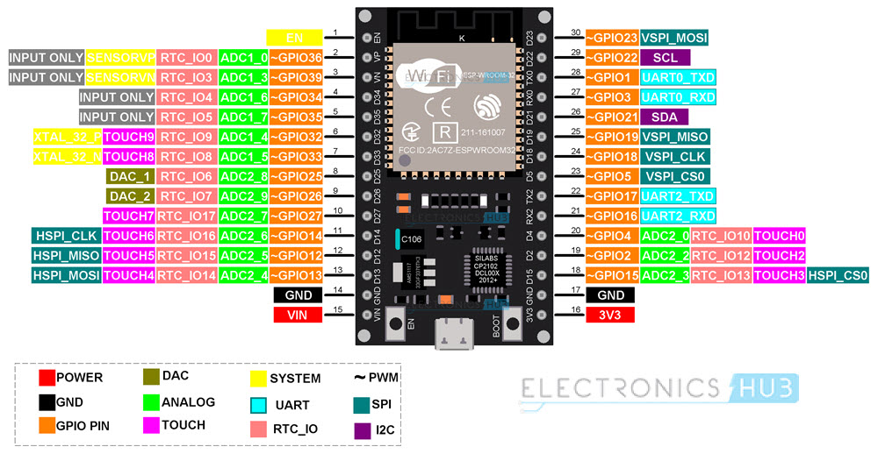  
           
           
           
           
           
           
           
           
           
           
           
           
           
           
           
           
           
           
           
           
           
           
           
         notice RXD2 – pin 16

and TXD2 – pin 17

* + - 1. EBYTE:  
         To connect the EBYTE via the FTDI we had to download a driver, using this tutorial: <https://www.youtube.com/watch?v=m1RTEAo6jRI&ab_channel=AtiMarem>  
           
         To set it up along with the esp32-wroom-32, we relied on the information in the manual (can be found on drive under Unit Tests/EBYTE e220-900t22d, or on the official website above). and this website for connection and libraries to install:

<https://www.mischianti.org/2022/03/11/ebyte-lora-e220-llcc68-device-for-arduino-esp32-or-esp8266-specs-and-basic-use-1/>

PIN connection:   
EBYTE -> ESP32/FTDI

RXD -> TXD  
TXD -> RXD  
GND -> GND  
VCC -> 3V3  
M0 -> GND  
M1 -> GND

*Note: we had to disconnect all the pins from the esp every time we wanted to upload code on it, otherwise we would get the following error:

“A fatal error occurred: Failed to connect to ESP32: Timed out waiting for packet header”

Fixed using:

https://stackoverflow.com/questions/70532139/how-to-fix-failed-to-connect-to-esp32-timed-out-waiting-for-packet-header-error

We ran this basic test on the two EBYTEs, the one connected to the esp and the one from the node (excluding the potentiometer in the video): <https://www.youtube.com/watch?v=n7quyu_YVcU&ab_channel=MicroPetabyNizarMohideen>

The exact code is available on the drive.

The boards we tried running it on were the “DOIT ESP32 DEVKIT V1” and “ESP32 Dev Module”.

Both devices were tested to transmit and receive (HW2 transmitter – HW6 receiver,  
HW6 receiver – HW2 transmitter) transmission was working only from the node’s EBYTE), we saw the LoRa message being transmitted on the serial monitor, but the receiving was not.  
  
We didn’t manage to send signals from the EBYTE device (HW2 and HW6) to the TTGO or vice versa, using the EBYTE basic code and the TTGO lora32 receiver code from the LoRa.h lib above and the basic receiver test (after updating RXD -> GPIO 01 and TXD-> GPIO 03 according to the TTGO schematics above).

Lastly, we found this video for Ebyte UART LoRa RF Settings, specifically to change the address key and frequency:

https://www.youtube.com/watch?v=n7quyu_YVcU&ab_channel=MicroPetabyNizarMohideen

**OUTPUT FROM STAND-ALONE MODEM**

HEAD : F0 1E 9D

AddH : 52

AddL : 3A

Chan : 112 -> 522MHz

SpeedParityBit : 10 -> 8E1

SpeedUARTDatte : 1 -> 2400bps

SpeedAirDataRate : 110 -> 38.4kbps

OptionSubPacketSett: 10 -> 64bytes

OptionTranPower : 10 -> 13dBm

OptionRSSIAmbientNo: 0 -> Disabled (default)

TransModeWORPeriod : 101 -> 3000ms

TransModeEnableLBT : 0 -> Disabled (default)

TransModeEnableRSSI: 1 -> Enabled

TransModeFixedTrans: 1 -> Fixed transmission (first three bytes can be used as high/low address and channel)

----------------------------------------

No response from device! (Check wiring)

12

----------------------------------------

HEAD: 46 69 120

Model no.: 65

Version : 64

Features : 20

----------------------------------------

Success

1

----------------------------------------

HEAD : C1 0 8

AddH : 0

AddL : 0

Chan : 23 -> 433MHz

SpeedParityBit : 0 -> 8N1 (Default)

SpeedUARTDatte : 11 -> 9600bps (default)

SpeedAirDataRate : 10 -> 2.4kbps (default)

OptionSubPacketSett: 0 -> 200bytes (default)

OptionTranPower : 0 -> 22dBm (Default)

OptionRSSIAmbientNo: 0 -> Disabled (default)

TransModeWORPeriod : 11 -> 2000ms (default)

TransModeEnableLBT : 0 -> Disabled (default)

TransModeEnableRSSI: 0 -> Disabled (default)

TransModeFixedTrans: 0 -> Transparent transmission (default)

----------------------------------------

Success

1

----------------------------------------

HEAD: C1 8 3

Model no.: 20

Version : B

Features : 16

----------------------------------------

F⸮dd^⸮⸮<⸮İ⸮⸮⸮@

No response from device! (Check wiring)

12

----------------------------------------

HEAD : F0 1E 9C

AddH : 12

AddL : 3A

Chan : 112 -> 522MHz

SpeedParityBit : 10 -> 8E1

SpeedUARTDatte : 1 -> 2400bps

SpeedAirDataRate : 110 -> 38.4kbps

OptionSubPacketSett: 10 -> 64bytes

OptionTranPower : 10 -> 13dBm

OptionRSSIAmbientNo: 0 -> Disabled (default)

TransModeWORPeriod : 101 -> 3000ms

TransModeEnableLBT : 0 -> Disabled (default)

TransModeEnableRSSI: 1 -> Enabled

TransModeFixedTrans: 1 -> Fixed transmission (first three bytes can be used as high/low address and channel)

----------------------------------------

Success

1

----------------------------------------

HEAD: C1 8 3

Model no.: 20

Version : B

Features : 16

----------------------------------------

Ft⸮⸮⸮x⸮Ƹ2 ⸮A ⸮

No response from device! (Check wiring)

12

----------------------------------------

HEAD : F0 1E 9D

AddH : 52

AddL : 3A

Chan : 112 -> 522MHz

SpeedParityBit : 10 -> 8E1

SpeedUARTDatte : 1 -> 2400bps

SpeedAirDataRate : 110 -> 38.4kbps

OptionSubPacketSett: 10 -> 64bytes

OptionTranPower : 10 -> 13dBm

OptionRSSIAmbientNo: 0 -> Disabled (default)

TransModeWORPeriod : 101 -> 3000ms

TransModeEnableLBT : 0 -> Disabled (default)

TransModeEnableRSSI: 1 -> Enabled

TransModeFixedTrans: 1 -> Fixed transmission (first three bytes can be used as high/low address and channel)

----------------------------------------

No response from device! (Check wiring)

12

----------------------------------------

HEAD: 46 69 120

Model no.: 65

Version : 64

Features : 20

----------------------------------------

⸮ADPeB0⸮⸮3⸮⸮

No response from device! (Check wiring)

12

----------------------------------------

HEAD : F0 1E 9D

AddH : 52

AddL : 32

Chan : 112 -> 522MHz

SpeedParityBit : 10 -> 8E1

SpeedUARTDatte : 1 -> 2400bps

SpeedAirDataRate : 110 -> 38.4kbps

OptionSubPacketSett: 10 -> 64bytes

OptionTranPower : 10 -> 13dBm

OptionRSSIAmbientNo: 0 -> Disabled (default)

TransModeWORPeriod : 101 -> 3000ms

TransModeEnableLBT : 0 -> Disabled (default)

TransModeEnableRSSI: 1 -> Enabled

TransModeFixedTrans: 1 -> Fixed transmission (first three bytes can be used as high/low address and channel)

----------------------------------------

No response from device! (Check wiring)

12

----------------------------------------

HEAD: 46 69 120

Model no.: 65

Version : 64

Features : 20

----------------------------------------

**OUTPUT FROM NODE**

----------------------------------------

HEAD : FE 14 FB

AddH : 2E

AddL : A

Chan : 251 -> 661MHz

SpeedParityBit : 11 -> 8N1 (equal to 00

SpeedUARTDatte : 100 -> 19200bps

SpeedAirDataRate : 1 -> 2.4kbps

OptionSubPacketSett: 10 -> 64bytes

OptionTranPower : 0 -> 22dBm (Default)

OptionRSSIAmbientNo: 1 -> Enabled

TransModeWORPeriod : 110 -> 3500ms

TransModeEnableLBT : 0 -> Disabled (default)

TransModeEnableRSSI: 1 -> Enabled

TransModeFixedTrans: 0 -> Transparent transmission (default)

----------------------------------------

No response from device! (Check wiring)

12

----------------------------------------

HEAD: 54 72 97

Model no.: 6E

Version : 73

Features : 70

**OUTPUT FROM SECOND NODE:**  
  
AddH : 3D

AddL : A7

Chan : 235 -> 645MHz

SpeedParityBit : 10 -> 8E1

SpeedUARTDatte : 101 -> 38400bps

SpeedAirDataRate : 11 -> 4.8kbps

OptionSubPacketSett: 0 -> 200bytes (default)

OptionTranPower : 10 -> 13dBm

OptionRSSIAmbientNo: 0 -> Disabled (default)

TransModeWORPeriod : 0 -> 500ms

TransModeEnableLBT : 0 -> Disabled (default)

TransModeEnableRSSI: 1 -> Enabled

TransModeFixedTrans: 1 -> Fixed transmission (first three bytes can be used as high/low address and channel)